Ambekeshwar Group of Institutions



Technology & Management, Lucknow

**Session: 2023-24**

Practical File

# **Branch:- CSE 2nd Year | 3rd Sem**

**Subject: - DCCN**

# **Name:- Suraj Arya**

# **Date:-**

Name Signature

Subject Teacher Mr. Rahul Singh ………………………

Class Co-Ordinator Miss. Fiza Hussain ………………………

Head of Department Miss. Richa Mishra ………………………

Academic Co-Ordinator Mr. Shivanshu Singh ………………………

INDEX

|  |  |  |  |  |
| --- | --- | --- | --- | --- |
| **S. no.** | **Name of Exp.** | **Date** | **Subject**  **Teacher**  **Sign** | **Academic**  **Co-Ordinator**  **Sign** |
| 1. | Recognize the physical topology and cabling (coaxial, OFC, UTP, STP) of a network. | 22/Sep/2023 |  |  |
| 2. | Recognition and use of various types of connectors RJ-45, RJ-11, BNC and SCST RJ-11 | 06/Oct/2023 |  |  |
| 3. | Identify the IP address of a workstation and the class of the address and configure the IP Address on a workstation. | 14/Oct/2023 |  |  |
| 4. | Managing user account in windows and LINUX. | 27/Oct/2023 |  |  |
| 5. | Connectivity troubleshooting using PING, IPCONFIG, IFCONFIG | 10/Nov/2023 |  |  |
| 6. | Create a network of at least 6 computers. | 18/Nov/2023 |  |  |

**PRACTICAL-1**

**AIM: Recognize the physical topology and cabling (coaxial, OFC, UTP, STP) of a network.**

**Recognize the physical topology**

A topology is basically a way to organize the network. The physical topology is the way you physically lay out the network, like a map, and the logical topology is the way the information flows on the network. Usually, the physical and logical topology is the same, but sometimes they can differ, such as in a physical star/logical ring topology.

**Star Topology:**

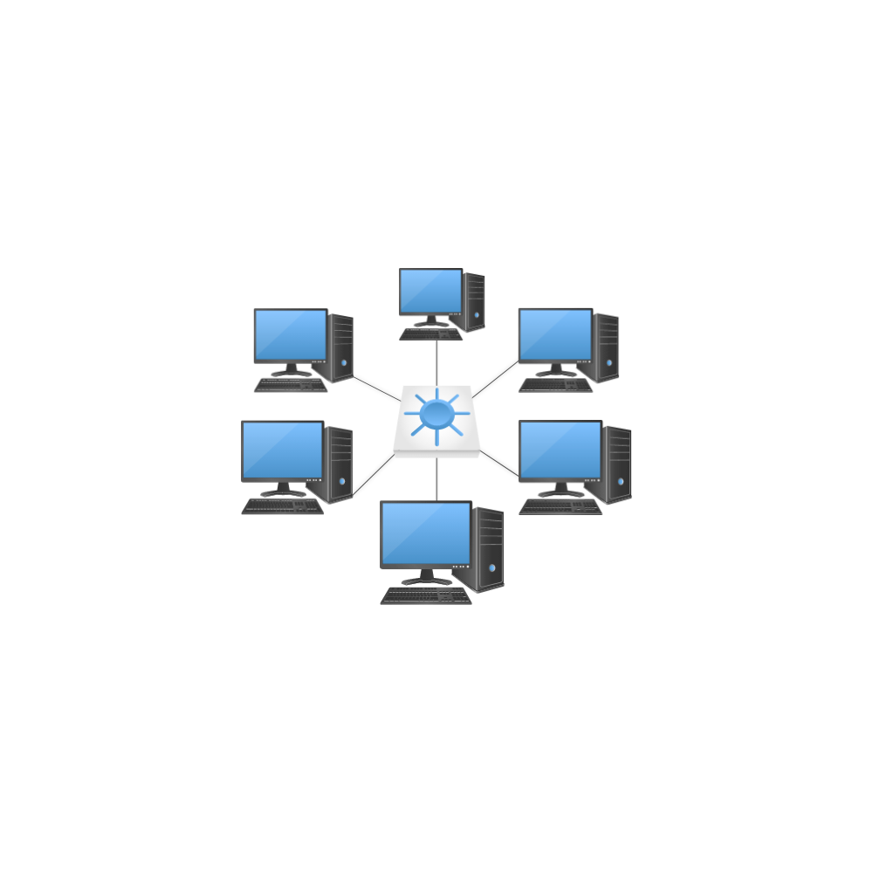Network where all nodes are connected to a centralized point (Hub or switch).

* **Used** with: 10BaseT.100BaseTX
* **Pros:** Cheap, easy setup and maintenance, reliable, and fault tolerant. Common wired standards of today.
* **Cons:** In a given collision domain (a hub-based network segment), all nodes receive the same Signal, giving rise to collisions and security concerns.

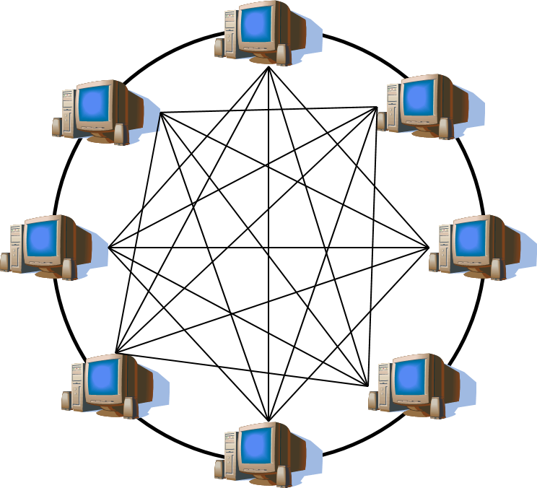**Mesh Topology:**

Mesh networks differ from other networks in that the different parts can all connect to each other via multiple hops. This allows for rerouting around broken paths by taking an alternate path to the destination. If all nodes in a mesh network are connected to every other node in the network, the networks known as fully connected.

* **Used with:** WANs (Wide Area Networks), including the Internet.
* **Pros:** Best fault tolerance available. If one node fails, the networks tilting.
* With some router protocols, traveling packets automatically find the quickest path to take in the network, given the meshed routes. Cons: Complicated.

**BUS Topology:**

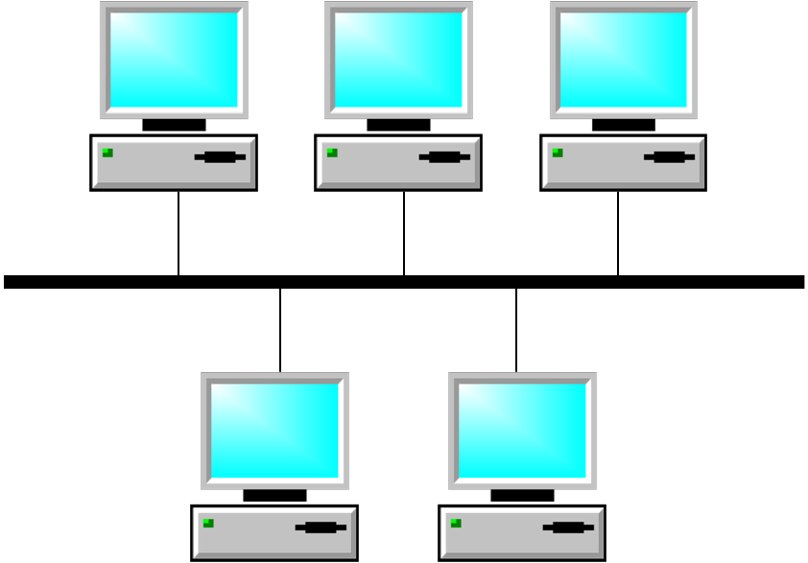Alternatively referred to as **line topology**, bus topology is a network setup where each computer and network device is connected to a single cable or backbone. Depending on the type of computer network card, a coaxial cable or an RJ-45 network cable is used to connect them together. Network in straight, linear sequence of nodes, terminated on both-ends.

* **Used with:** 10BASE5(Thick-net), 10BASE2 (Thin-net)
* **Pros:** Good for small networks. Now considered obsolete.
* **Cons**: More expensive than-the common base Network . Like Ring- based networks, if one node fails, the entire network goes-down.Difficult to troubleshoot. Cables need to be terminated on both ends with terminating devices.

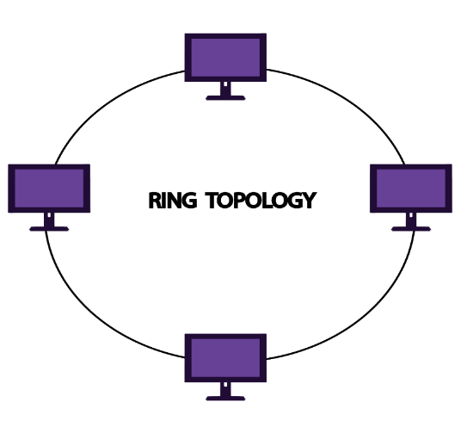**Ring Topology:**

Network in the form of a ring, where the packets (tokens) move to the next node in the Only one node has-the token at any one time. This is usually a logical token ring with a physical star topology.

* **Used with**: FDDI(Fibre Distributed Data Interface) and Token Ring.
* **Pros:** Low signal degeneration. Since only one node can pass the token at any one time, it inherently reduces collisions significantly.
* **Cons:** Expensive. Difficult to find a problem segment. If one node fails, whole network goes down. Dual-ring implementations provide redundancy and makes failures less likely.

**Pear to Pear**

A switch provides a series of point-to-point circuits, via micro segmentation, which allows each client node to have a dedicated circuit and the added advantage of having full duplex connections.

**Point-to-multipoint**

A hub provides a point-to-multipoint (or simply multipoint) circuit which divides the total bandwidth supplied by the hub among each connected client node. This topology is seen in ATM (Asynchronous Transfer Mode) and Frame Relay links, as well as X.25 networks when used as-links for a network layer protocol like IP (Internet Protocol).

**Hybrid**

Hybrid networks use a combination of any two or more topologies in such a way that the resulting network does not exhibit one of the standard topologies(e.g., bus, star, ring, etc.). For example, a tree network connected to a tree network is still a tree network, but two-star networks connected together exhibit a hybrid network topology. A hybrid topology is always produced when two different basic network topologies are connected. Two common examples for Hybrid network are: star ring network and star bus network.

A Star Ring network consists of two or more-star topologies connected using a MAU (Media Access Unit) as a centralized hub. A Star Bus network consists of two or more-star topologies connected using a bus trunk (the bus trunk serves as the network's backbone).

**Recognize the cabling**

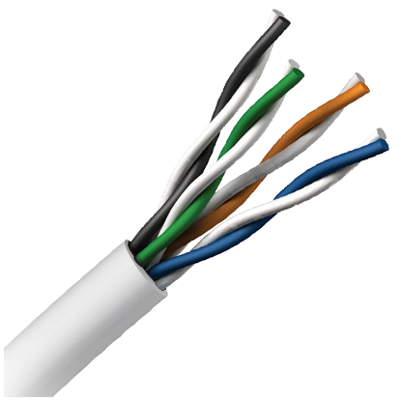Signal-to-noise ratio despite interference from both external sources and other pairs.

**UTP (Unshielded Twisted pair):**

Eight copper wires twisted into four color-coded pairs and then wound inside a jacket to reduce crosstalk.

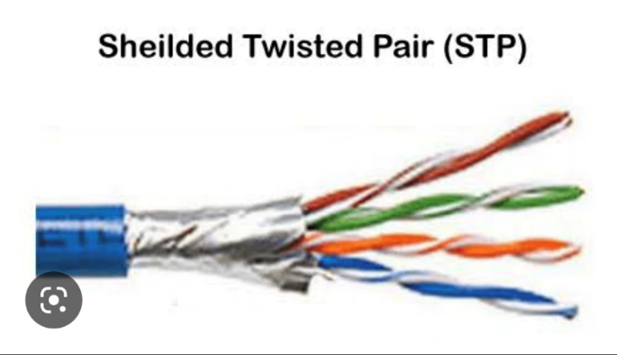**STP (Shielded Twisted Pair):**

Eight copper wires twisted into four color coded pairs and then wound inside a shield of wire mesh to prevent electromagnetic interference.

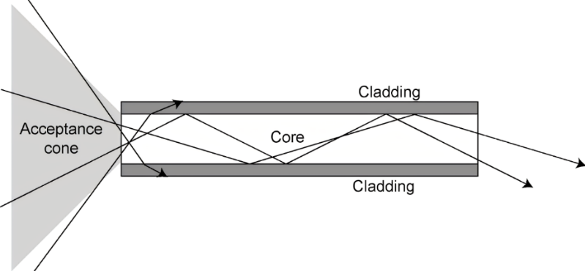**Optical Fiber**:

In fiber-optic communication, a multimode fiber is a type of optical fiber mostly used for communication over shorter distances, such as within a building or on a campus. More than one signal can be transmitted at a time by bouncing the light off of the wall soft he core because of the size of its core, greater than 10 microns. It can be made of glass or plastic, as the tolerances required over shorter distances allow for the use of plastic. The shorter distance also allows for the use of a laser or a-less expensive LED (light emitting diode) as the source of light traveling through the fiber**.**

|  |  |
| --- | --- |
| **Speed** | **Distance** |
| 100 Mbit/s | 2 kilometers |
| 1 Gbit/s | 550 meters |
| 10 Gbit/s | 300 meters |

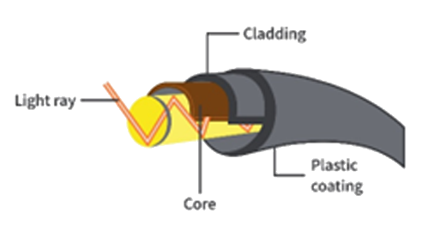Duplex: Full (one fiber each direction) Noise immunity: not susceptible to electromagnetic interference.

1. Core: 8 u diameter
2. Cladding: 125 media.
3. Buffer: 250 Umida.
4. Jacket: 400 Umida.

In fiber-optic communication, a single-mode optical fiber (SMF) is an optical fiber designed to carry only a single ray of light (mode) over a great distance. Its core measures 8-10 microns and allows for less dispersion of light than multimode fiber. It requires the use of a laser in order to reach long distances at high speeds.

**Transmission speed:** up to 10 Gbit/s

**Distance**: 40 kilo-meters

**Duplex**: Full (one fiber each direction)

**Noise-immunity**: not susceptible electromagnetic interference

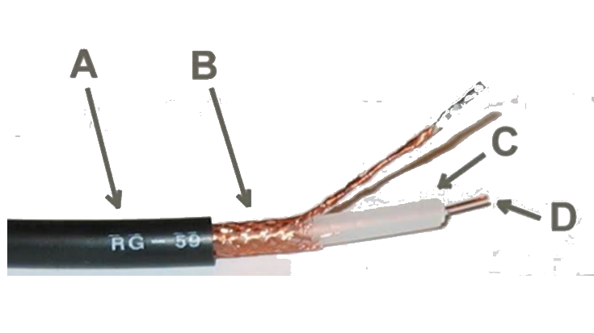A : Outer plastic-shield

B : Copper braid shield

C : Inner dielectric insulator

D : Copper-core

**PRACTICAL - 2**

**AIM:** Recognition and use of various types of connectors RJ-45, RJ-11, BNC and SCST RJ-11

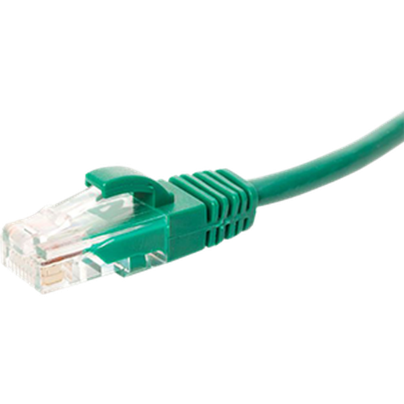**(Registered Jack 11)**

RJ-11 is a physical interface often used for terminating telephone wires. It is probably the most familiar of the registered jacks, being used for single line.

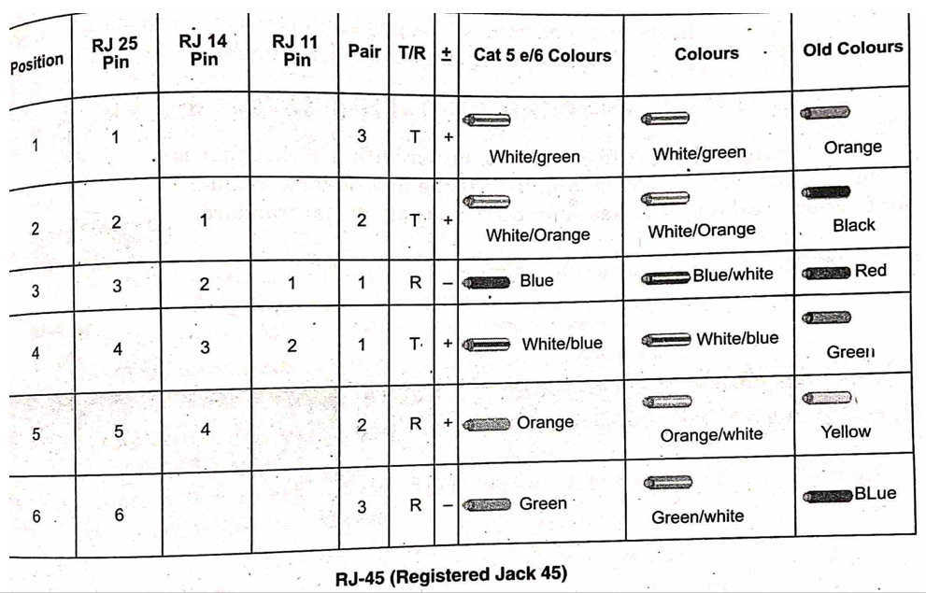

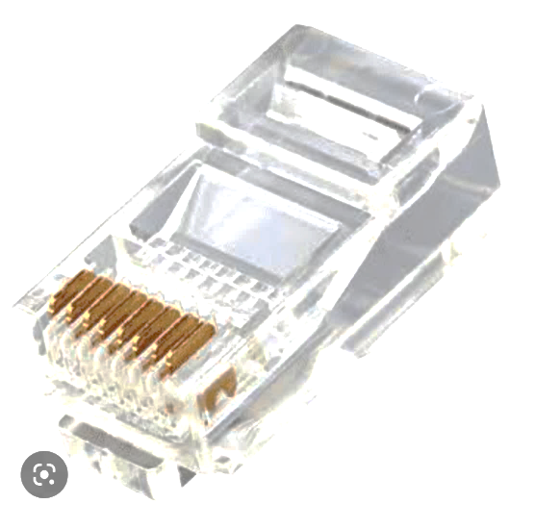**Plain Old Telephone Service (POTS)**: Telephone jacks in most homes across the world. RJ-14 is similar, but for two lines, and RJ-25 is for three lines. The telephone line cord and its plug are more often a true RJ-11 with only two conductors.

The 8 Position 8 Contact (8 P8C) (often incorrectly called RJ-45) plugs and sockets are most regularly used as an Ethernet connector. 8P8C connectors are typically used to terminate twisted pair cable.

**BNC (Bayonet Neill-councilman)**. The BNC (Bayonet Neill-Councilman) connector is a very common type of connector used for terminating coaxial cable. The BNC connector is used for RF signal connections, for analog

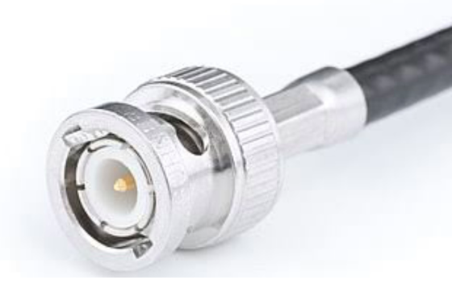 and digital video signals, amateur radio antenna connections, aviation electronics (avionics) and many other types of electronic test equipment. It is an alternative to the RCA connector when used for composite video on commercial video devices, although many consumer electronics devices with RCA jacks can be used with BNC-only commercial video equipment via a simple adapter.

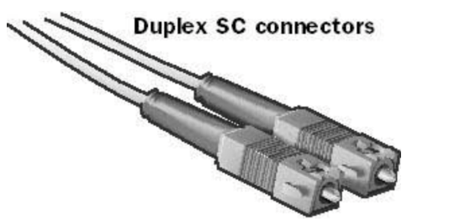**SC (Subscriber Connector or Standard Connector).** A fibre-optic connector with a push-pull mechanism to allow locking in place while still being simple to insert and remove.

**ST (Straight Tip).** A fibre-optic connector with a socket that is locked in place with a bayonet lock. ST was the first de-facto standard for fibre-optic cabling, and has since been made an official standard.

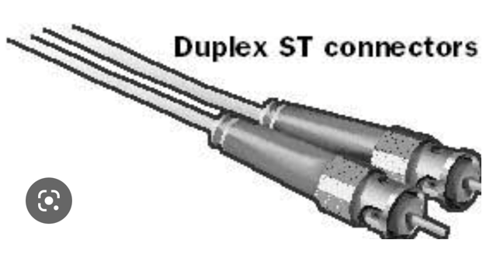

**PRACTICAL:- 3**

**AIM: Identify the IP address of a workstation and the class of the address and configure the IP Address on a workstation.**

**Identify the Ip address of a workstation**

1. 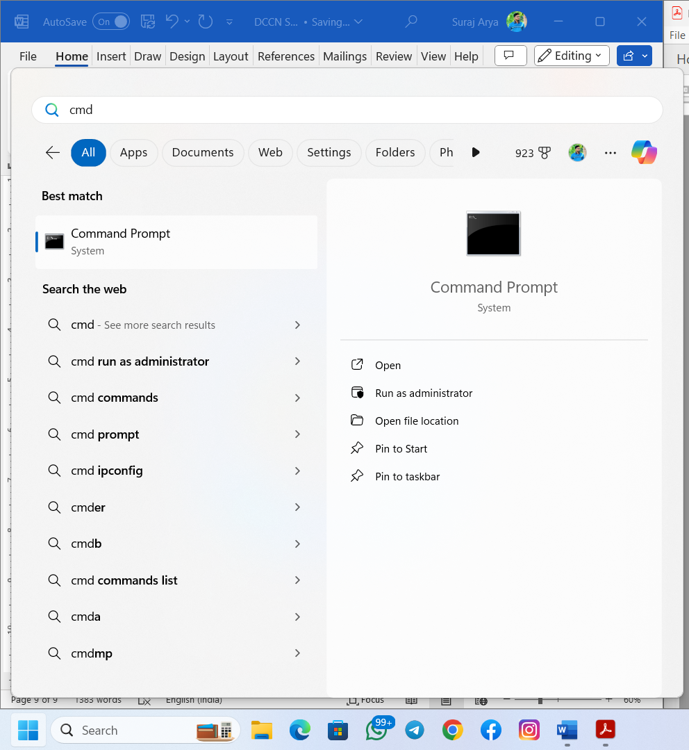Click the start button, type “cmd”, then press Enter.
2. The Command Prompt window will open, which you can type operating system commands through.
3. Type “ipconfig” and press Enter.
4. 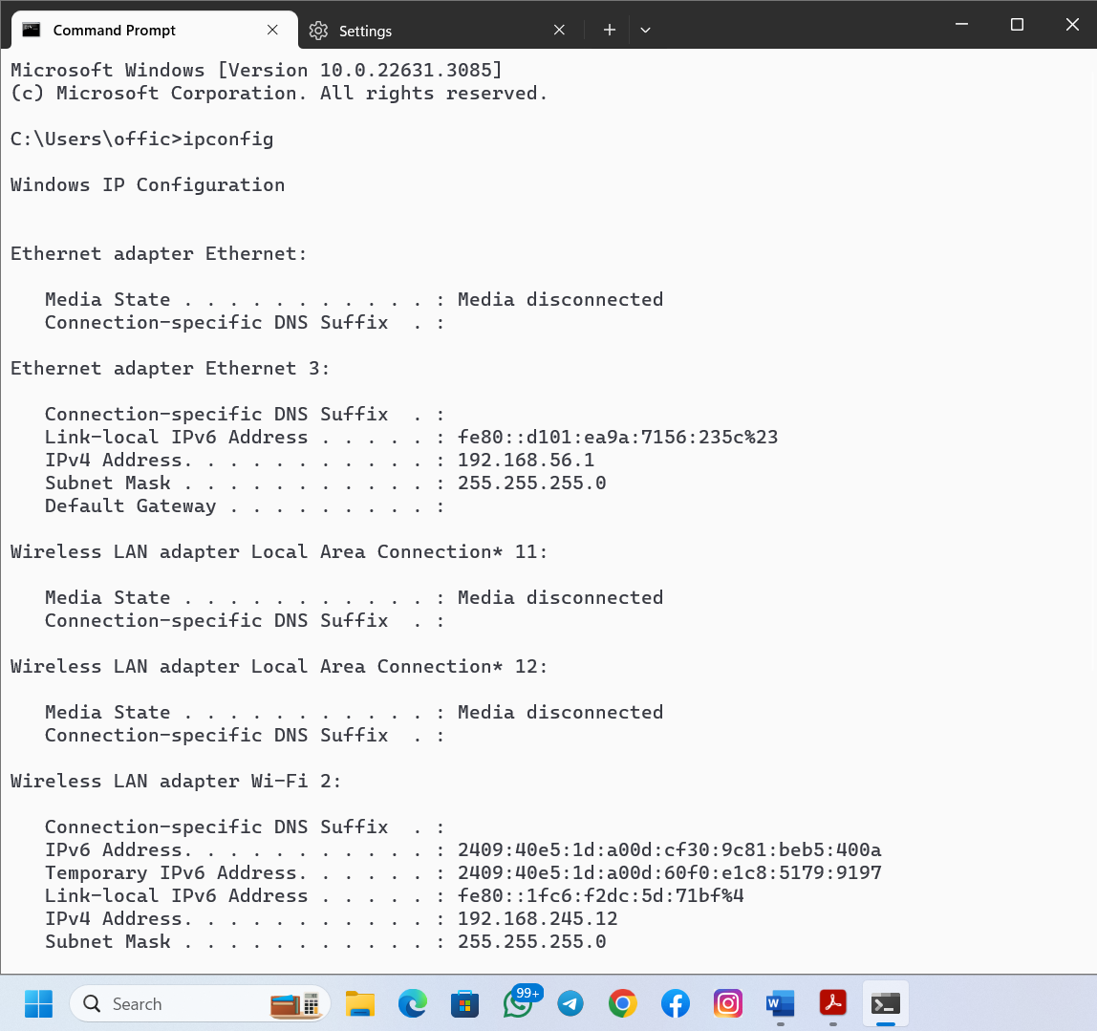Look for the line that says “IPv4 Address,” right above “Subnet Mask” If you’re looking for the IP address of a home computer, the IP address will look something like 192.168.1.###, where only the last three numbers will vary from computer to computer.

**Identify IP Address on a workstation**

**Result**

Thus we Identify the IP address of a workstation and the class of the address and configure the IP Address on a workstation.

**Practical No:- 4**

**AIM : Managing user account in windows and LINUX.**

**Window**

**Create New User Account**

**Step 1:** Click on start button.

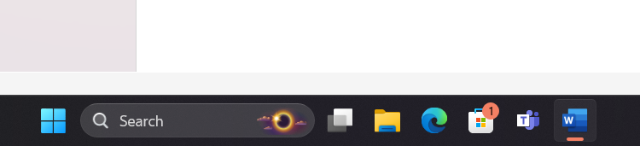

**Step 2:** Search Control panel

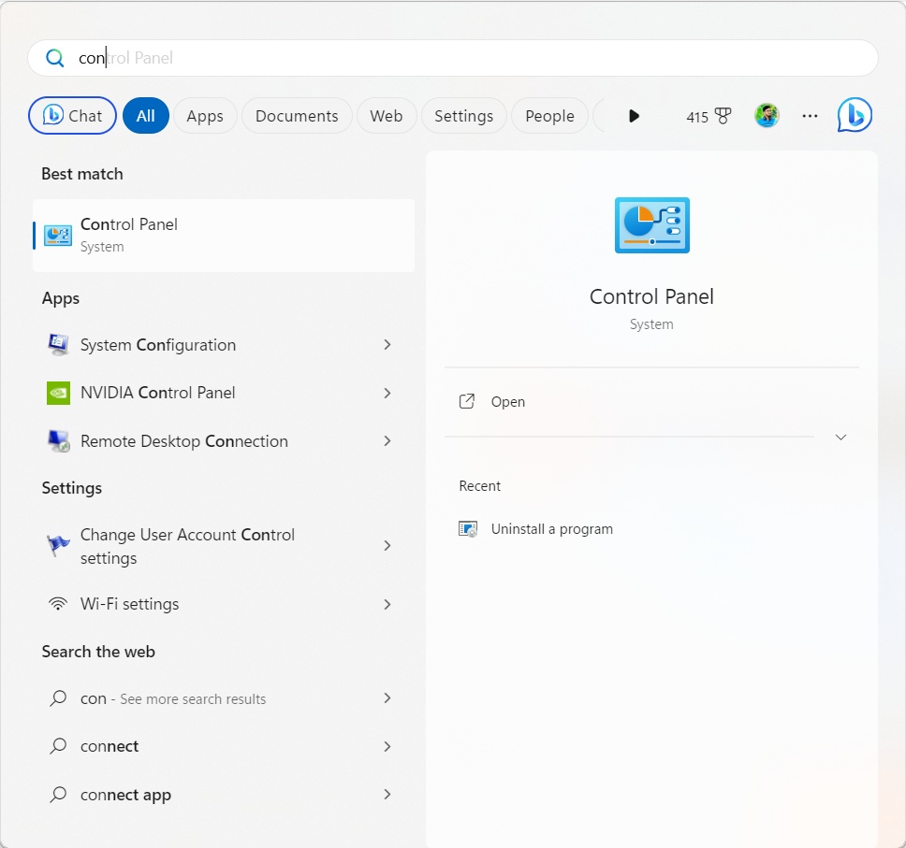

**Step 3:** Click on change account type.

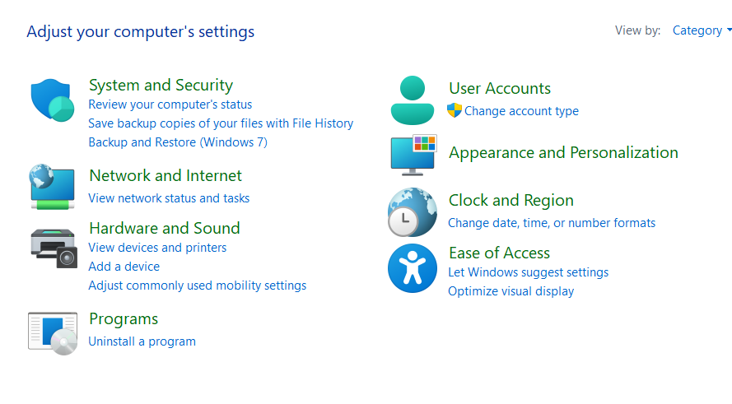

**Step 4:** Click on Add a new user in PC

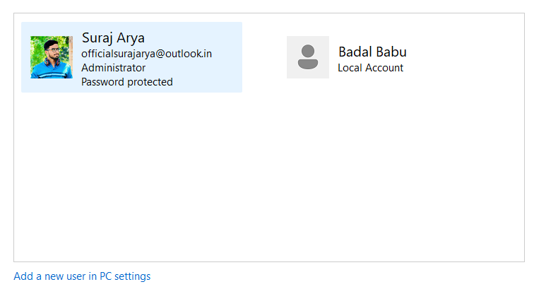

**Step 5:** Enter a **user name**. & if you want to **make it secure**

then also enter **Password** and then **click Next**

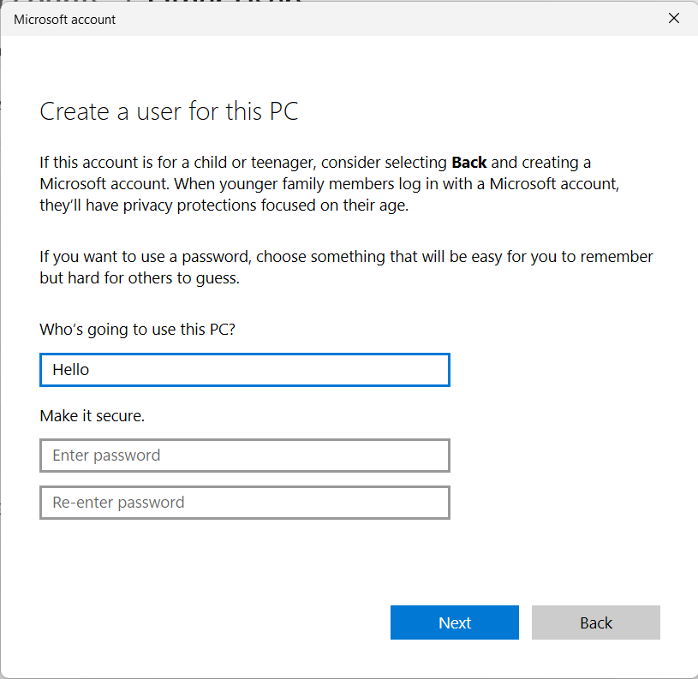

**Step 6:** Your New Account has been Created

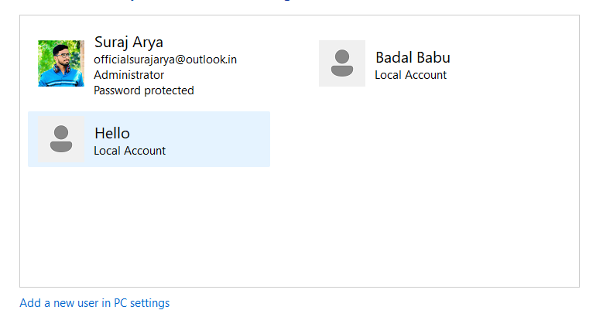

This is your new user Account

**Delete User Account**

**Step 1 :** For Deleting user Account Click on User

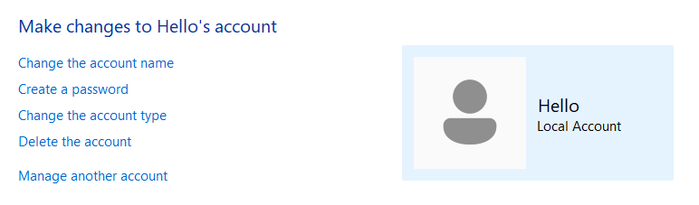**Step 2:** Click on Delete the Account

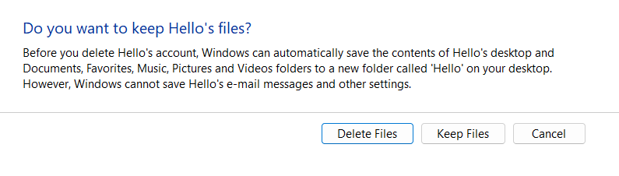**Step 3:**  If you want ko keep your user data, then click on **keep files** otherwise click on **Delete Files**

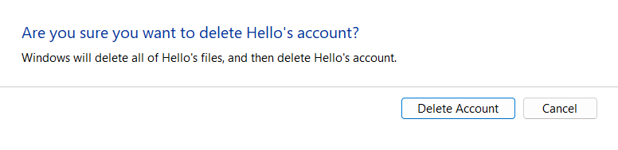**Step 4:** In last again hit enter

**Create New User Account In LINUX**

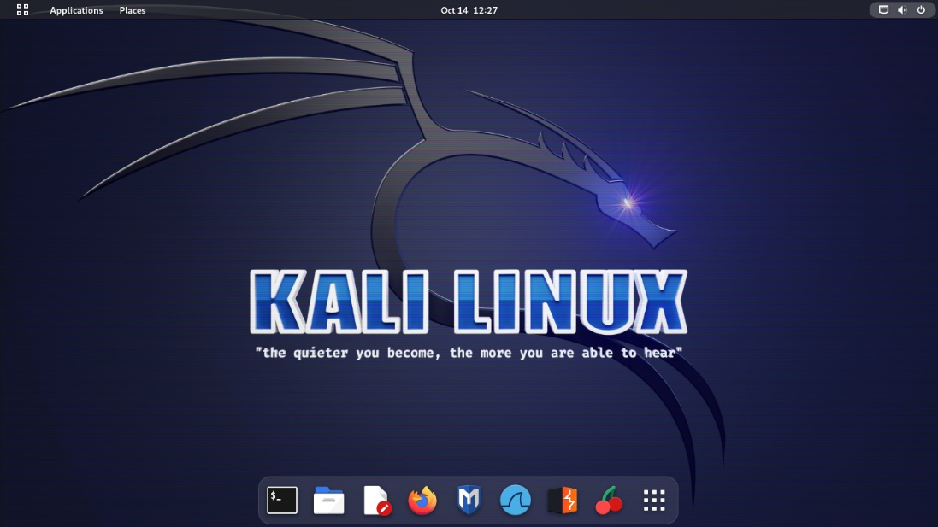**Step 1:** Click on the top right corner

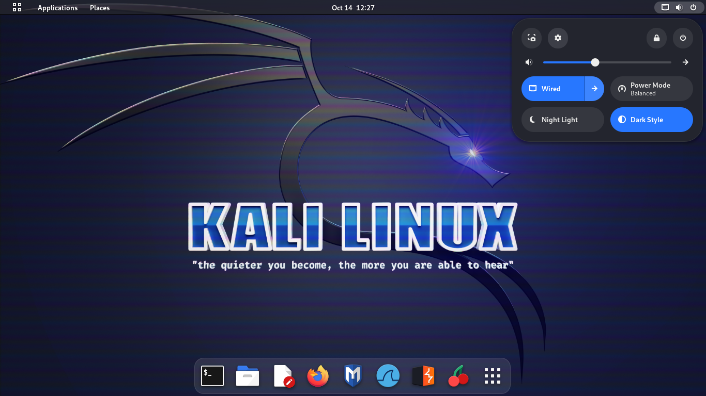**Step 2 :** Click on Settings

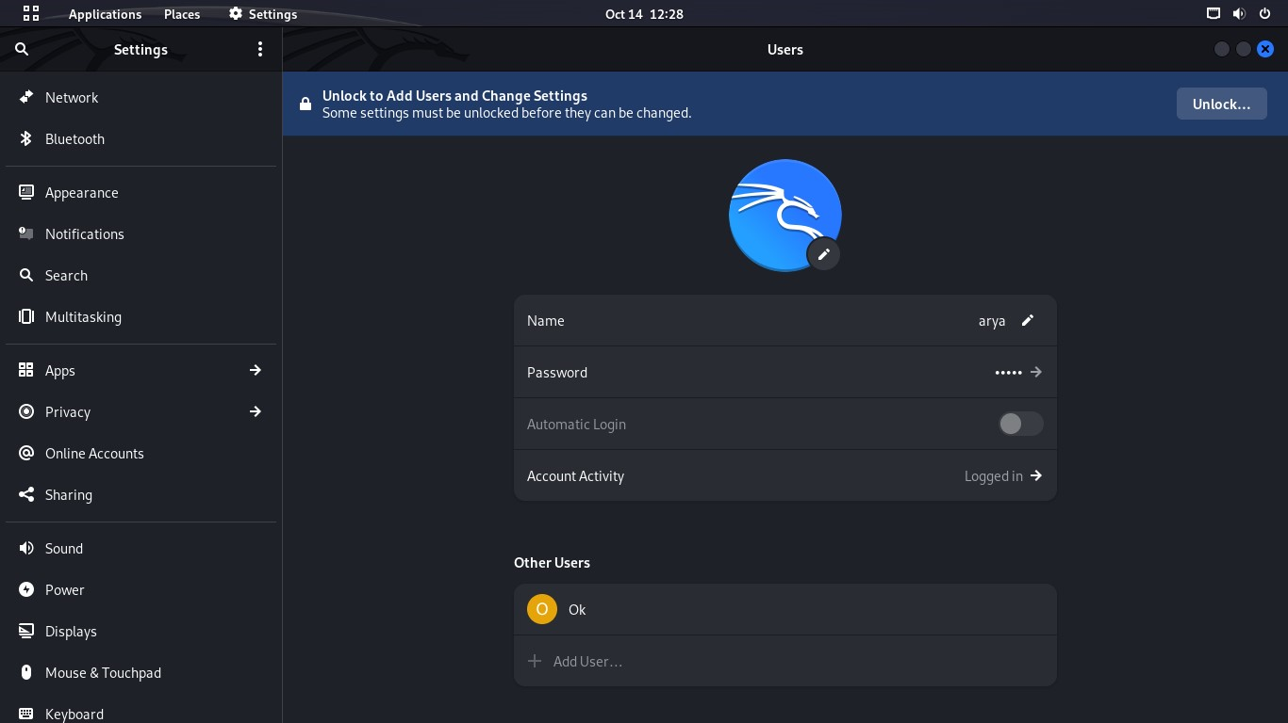 **Step 3:** Click on Unlock

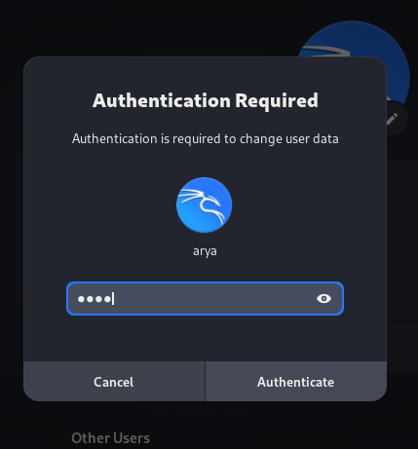 **Step 4:** Enter your current user password then hit Enter

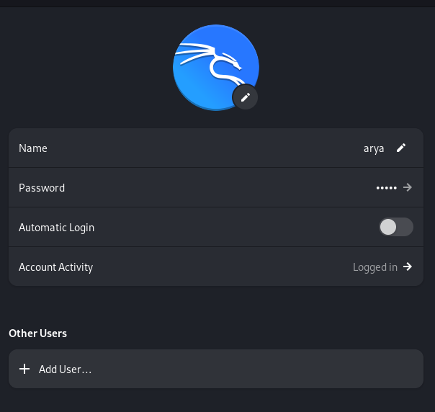**Step 5 :** Click on Add user

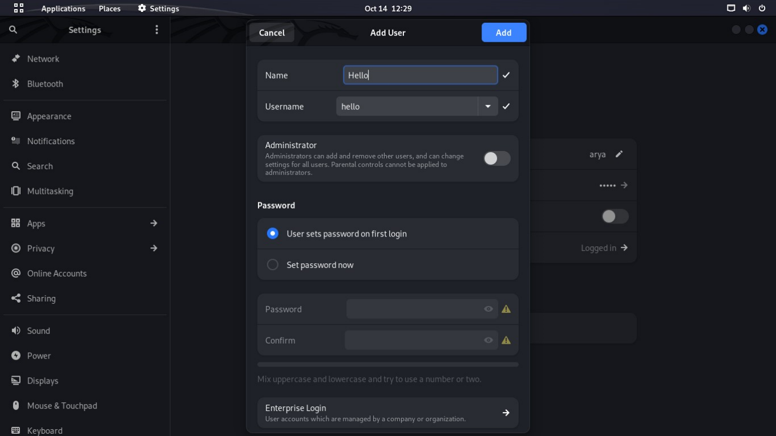**Step 6 :** Enter a **user name** & if you want to **make it secure** then also enter **Password** and then **click Add**

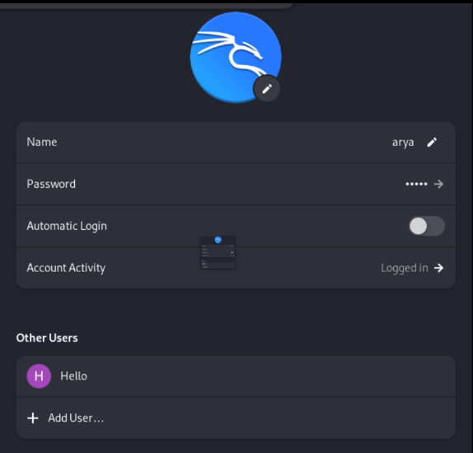**Step 7: Your new user Account is been created**

**Delete user account in LINUX**

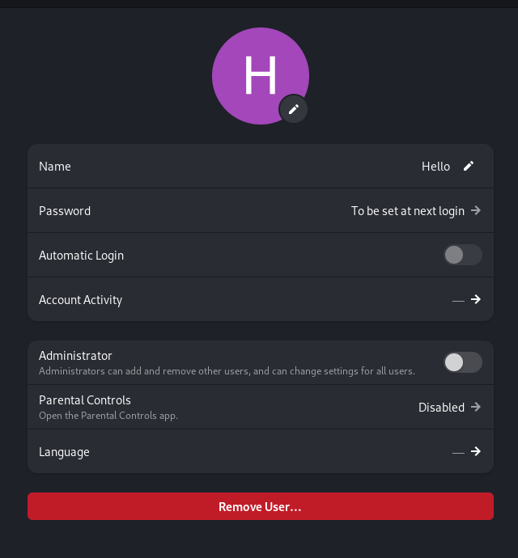**Step 1:** Click on user then Click Remove User

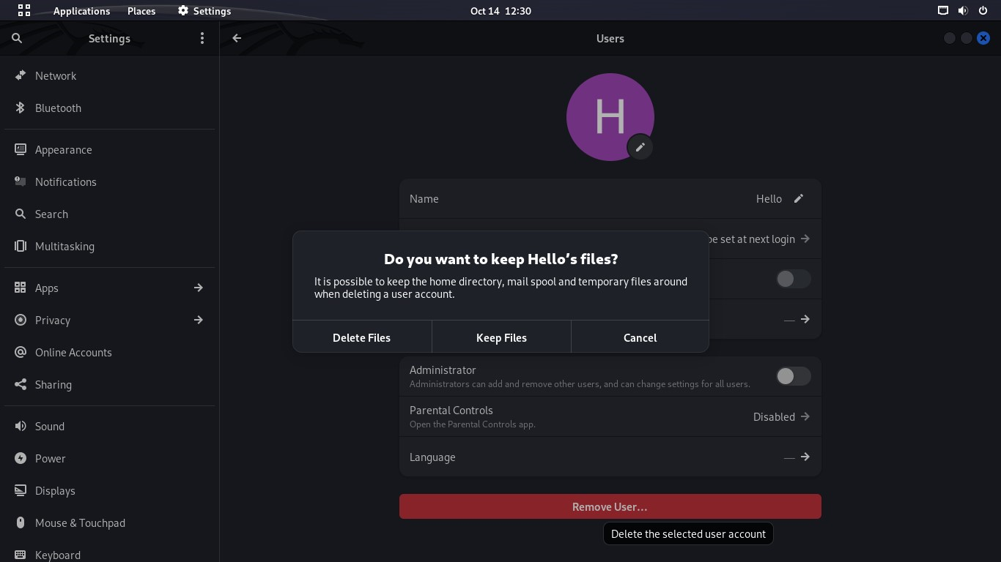**Step 2:** If you want ko keep your user data, then click on **keep files** otherwise click on **Delete Files**

**Step 3 :** Your User Account is Deleted

**Practical No:- 5**

**AIM : Connectivity troubleshooting using PING, IPCONFIG, IFCONFIG**

**Procedure:**

**Configure Internet connection and use IPCONFIG, PING:**

1. Open Command Prompt, and then type ipconfig. From the display of the ipconfig command, ensure that the network adapter for the TCP/IP configuration you are testing is not in a Media disconnected state.
2. At the command prompt, ping the loopback address by typing ping 127.0.0.1.
3. Ping the IP address of the computer.
4. Ping the IP address of the default gateway. If the ping command fails, verify that the default gateway IP address is correct and that the gateway (router) is operational.
5. Ping the IP address of a remote host (a host that is on a different subnet). If the ping command fails, verify that the remote host IP address is correct, and that all of the gateways (routers) between this computer and the remote host are operational.
6. Ping the IP address of the DNS server.

If the ping command fails, verify that the DNS server IP address is correct that the DNS server is operational, and that all of the gateways (routers) between this computer and the DNS server are operational.

**Tracer to debug the network issues.**

Tracer network:

Open Command Prompt, and type the following:

tracert host_name

Or

tracert ip address

where host name or ip address is the host name or IP address, respectively, of the remote computer.

If you do not want the tracert command to resolve and display the names of all routers in the path, use the -d parameter. This expedites the display of the path. For example to trace a path from this computer to www.microsoft.com without displaying the router names, type the following at a command prompt:

**Net stat utilities to debug the network issues:**

Displays active TCP connections, ports on which the computer is listening. Ethernet statistics, the IP routing table, IPv4 statistics (for the IP, ICMP, TCP, and UDP protocol and IPv6 statistics (for the IPv6, ICMPv6, TCP over IPv6, and UDP over IPv6 protocol Used without parameters, netstat displays active TCP connections

**Syntax**

**netstat [-a] [-e] [-n] [-o] [-p Protocol] [-r] [-s] [Interval]**

**Parameters**

**-a:** Displays all active TCP connections and the TCP and UDP ports on which the computer is listening.

**-e:** Displays Ethernet statistics, such as the number of bytes and packets sent and received. This parameter can be combined with -s.

**-n:** Displays active TCP connections, however, addresses and port numbers are expressed numerically and no attempt is made to determine names.

**-0:** Displays active TCP connections and includes the process ID (PID) for each connection. You can find the application based on the PID on the Processes tab in Windows Task Manager. This parameter can be combined with -a, -n, and -p.

**-p Protocol:** Shows connections for the protocol specified by Protocol. In this case, the Protocol can be tep, udp, tcpv6, or udpv6. If this parameter is used withs to display statistics by protocol, Protocol can be tcp, udp, icmp, ip, tepv6, udpv6, icmpv6, or ipv6.

**-s:** Displays statistics by protocol. By default, statistics are shown for the TCP, UDP, ICMP, and IP protocols. If the IPv6 protocol for Windows XP is installed, statistics are shown for the TCP over IPv6, UDP over IPv6, ICMPv6, and IPv6 protocols. The p parameter can be used to specify a set of protocols.

**-r:** Displays the contents of the IP routing table. This is equivalent to the route print command.

**Interval**

Redisplays the selected information every Interval seconds. Press CTRL+C to stop the redisplay. If this parameter is omitted, netstat prints the selected information only once.

Displays help at the command prompt

**Result:**

Thus, the Configure Internet connection and use IPCONFIG, PING/ Tracer and Net stat utilities to establish interconnection between systems have been done successful.

**Practical No: - 6**

**AIM: Create a network of at least 6 computers.**

Thus, we create a network of at least 6 computers.

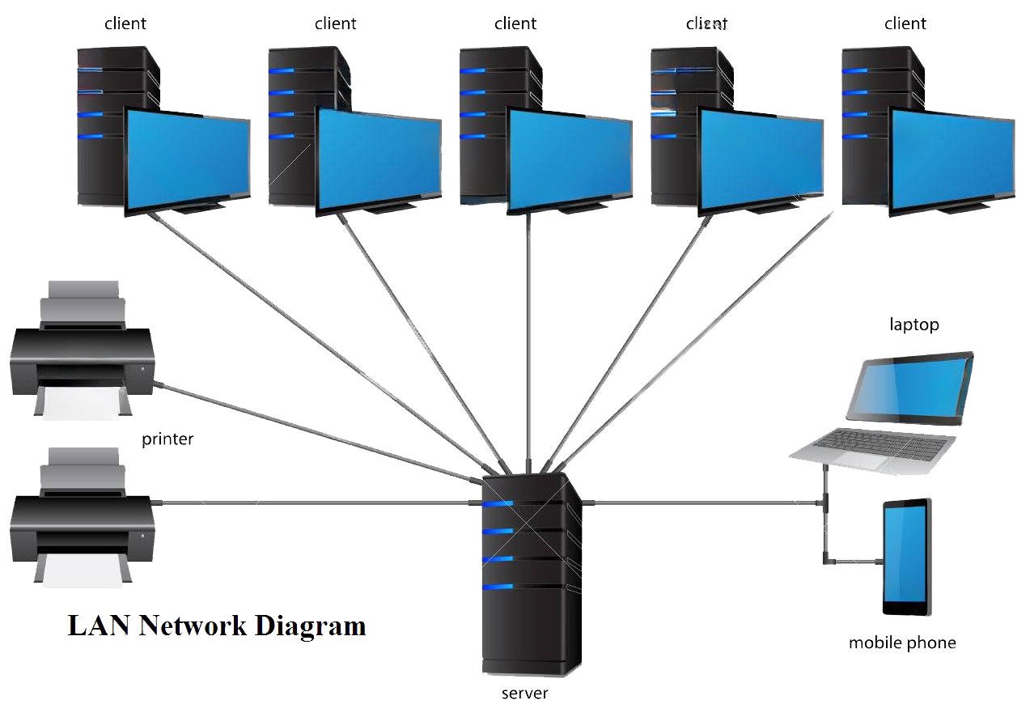

**Fig: LAN Network Diagram**

First of all in order to connect a computer to an Ethernet cable, the computer must have an intrface. In a desktop this is usually a Network Interface Card (NIC) or USB adapter.

In a laptop, it is usually a PC card, a modle that plugs into the laptop. The Ethernet jack may also be built into the laptop itself.

**Procedure:**

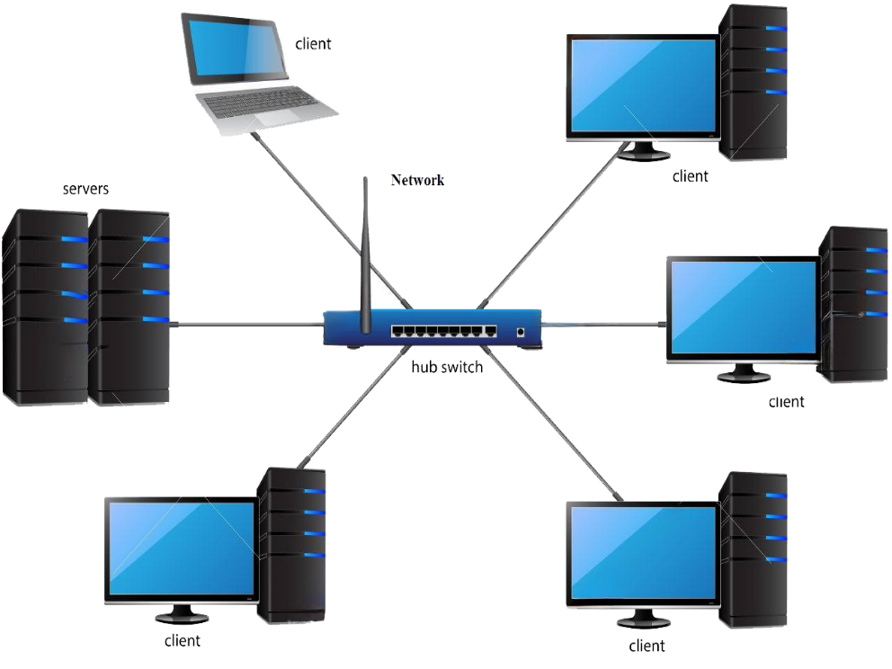

1. Take the computer for which you are making server, insert the second LAN in that computer.
2. Connect your internet connection into the first LAN (inhibit) on that computer.
3. Now open your second LAN properties and go to the TCP IP properties and there enter IP address as (192.168.0.1) or anything you wish Subnet Mask (255.255.255.0) and the gateway as (192.168.0.1).
4. Now open click on the switch and you will get a notification on your server saying that 'Local Area Connection 2' is connected.
5. Now take an another Internet cable and one end of that cable should be in any one port of the Switch and the outer should be in the second computer.
6. Now you will get a notification that you ae connected to internet, open the LAN properties and enter the IP address as (192.168.0.2) subnet mask and gateway should be same as server, say ok.
7. You will now be able to browse Internet on that particular system now.
8. Do the same with the rest of the systems.
9. And one more thing should be kept in mind that is you want be able to browse internet. Unless or Until your Server PC is turned on.

**RESULT**

Thus, we create a network of at least 6 computers.